Derwent Runners Cross Country Event
– Allestree Park Sunday 10th January 2016

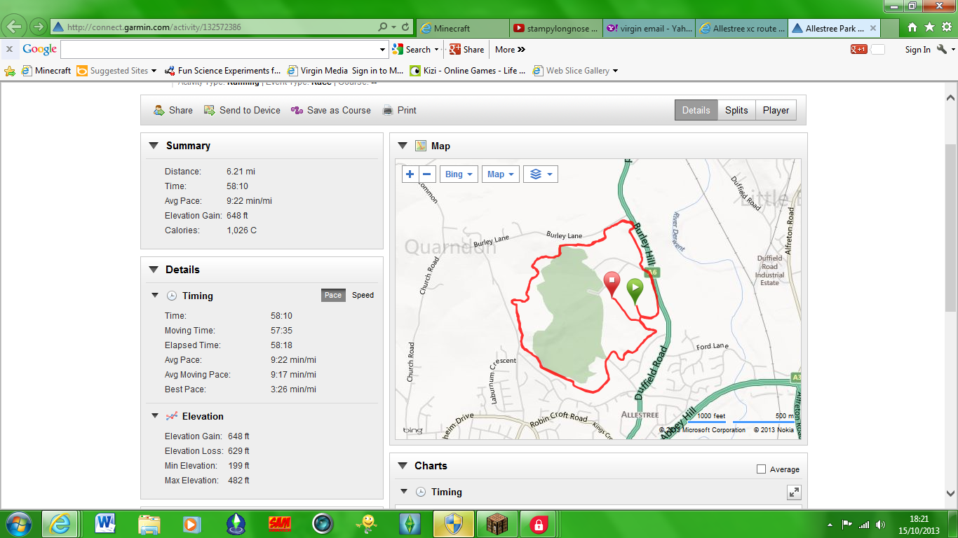
M78
M6
M5
M4
M3
M221
M9
M111
M8
M10
Start
Finish
3 stakes
3 stakes
3 stakes
3 stakes
3 stakes
3 stakes
3 stakes
3 stakes
3 stakes
3 stakes
Gate
Need lots of tape on trees
Rabbit hole – stake and tape
3 stakes + arrow
Wooden bridge over stream, then steps
Steep steps
Xmas tree steps
3 stakes. Onto main path – arrow.
Uphill
Arrow left
2 x slippy bridges
3 stakes
Car park
Arrow
GOLF!
Arrow on posts
Stake and Arrow
LAKE!

M1 Ian Mosley
First corner on first lap. Second lap – direct runners back round field
M2 Anne-Marie
On road into park directing runners across the road, asking any cars coming along to slow down
M3 Steve Spelman
At 90 degree right turn making sure runners don’t go straight on into park
M4 Barry Warwick
At 90 degree turn left just before slippy bridge – warn runners to take care
M5 Kev White
Top of incline – direct to runners’ right
M6 Phil Holmes
Direct runners to their right – tell them to turn left at arrow
M7 Debbie Hamp
Runners will look for you as they come through open area – direct them to your right
M8 Mark Gray
Stand at crossroads of paths – direct towards lake, telling them to turn round when they get there. Keep an eye out for walkers.
M9 Claire Hart-Oakes
Sharp turn at end of lake
M10 Ian Schofield
First lap – direct back to starting field for second lap. Second lap – direct towards finish.

